TITLE OF SCHOOL/ ORGANISATION




VIVA- GO © VALUES COACHING

NAME OF CHILD: CLASS:

We would like to offer your child some VIVA-GO values coaching. This will be either a one to one or group basis. This will be 3, 6 or more sessions, once a month with check-ins, in school

How will it help my child?

VIVA-GO is creative, fun coaching which will help your child develop reflection, responsibility and resilience in their learning and relationships.

How does it work?

We start with your child’s VIVA. We explore what is important to your child; their
Values, Inspirations, Vision and Attributes.

We then help them use their VOICE to discover a good target for themselves for the next month.
(Vision, Obstacles, Inside feelings, Choices, Effort), and find steps to success for their own target.

Feedback

Your child will share their VIVA-GO target and actions with you. This will be on a postcard.
They will enjoy having your help with each challenge they have set for themselves
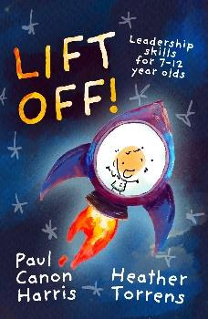

How did VIVA-GO start?
‘Lift off!’ leadership skills’ was written with the help of some young leaders. One young boy in the group found it difficult to lead others because he could not lead himself! His life experiences affected his learning, patterns of behaviour and relationships. Through supported encouragement, he discovered his own values, strengths and strategies. By the end of the year he was given a leadership role, by peers and senior leaders.
This was the inspiration for VIVA-GO coaching. It was developed through an Oxford University scholarship and Exeter University SENCO Action research.
It has been piloted by many schools.

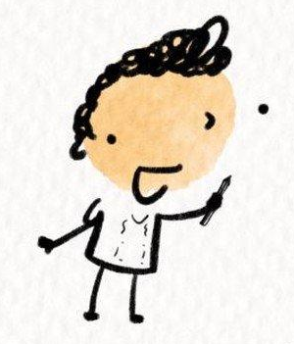
Thank you,

Name of coaching lead

TITLE OF SCHOOL/ ORGANISATION
School/ organisation logo here

VIVA-GO Coaching Contract

Please read it carefully.

If you have any questions at all, please feel free to email or phone coaching lead before you sign it.

email: coaching lead
School phone: _______________

What is coaching?

Coaching is unlocking a person's potential to help them be the best they can be, and better than their best! It is helping them to learn rather than teaching them.

When and where?

This will take place once a month in school, for 30 minutes, with follow up check- ins.

Confidentiality

The coaching sessions will be confidential, except in cases where there is a safeguarding issue which means a child or person is at risk. In this case, I will be required to report this to appropriate persons.

Please complete and return the signed agreement form.

 …………………………………………………………………………………………………………….

Date……………………………

I would like my child ……………………………………… Year……… Class………………………

to take part in VIVA-GO coaching sessions.

What I would like my child to gain from coaching, E.G Greater confidence, learning progress, support for additional learning or Social, Emotional, Mental Health needs.

…………………………………………………………………………………………………………………

…………………………………………………………………………………………………………………

Please print name____________________________________

Signed _____________________________________ Date ___________

