
 News Release
29th November 2022
Bournemouth School’s Work Tackling Global Poverty Recognised with Christian Aid Award
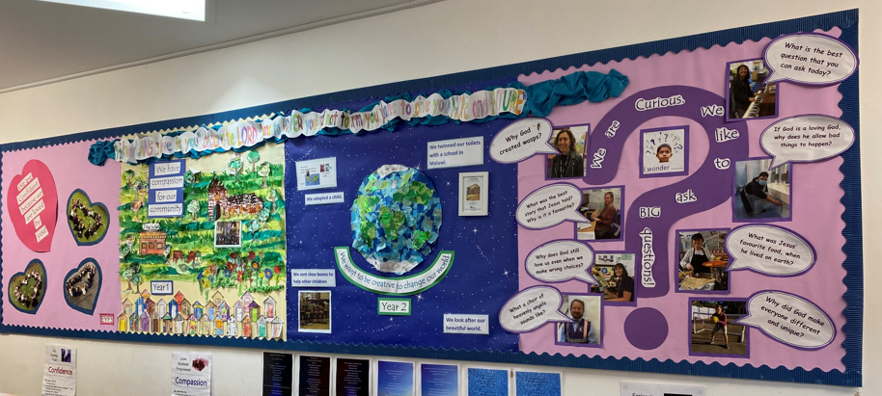
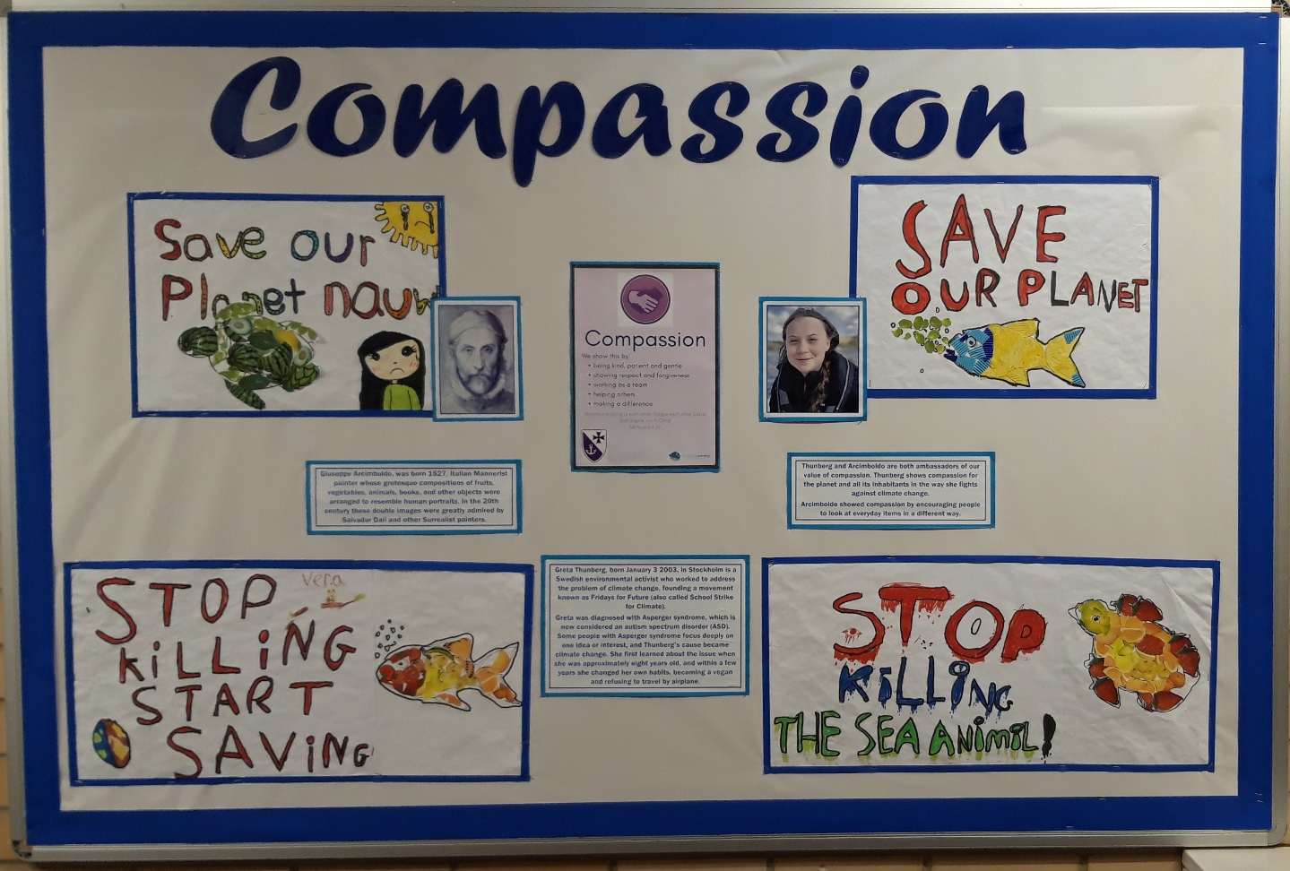

St Clements and St John’s Infant and Bethany CE Junior Schools have been presented with a Bronze Award from Christian Aid’s Global Neighbours Scheme for their global citizenship work.
From recycling, composting and beach cleans to donating food for local people, pupils and staff at St Clement’s and St John’s Infant School have been working hard to take their place as global citizens, while sister school Bethany Junior have also been recycling, saving energy, limiting the use of plastic and taking part in a reverse advent calendar,
St Clement’s and St John’s Church of England Infant School and Bethany CE junior School in Bournemouth have achieved Bronze Award status in Christian Aid’s Global Neighbours scheme in recognition of its wide-ranging steps to love their global neighbour.
The accreditation scheme celebrates schools that are helping pupils learn about global poverty and the Christian responsibility to tackle it, as well as giving them the tools to play a confident part in creating a fairer world.
Andy Poole, Head teacher of St Clement’s and St John’s said:

"We are so pleased that Christian Aid have recognised the work we are doing at St Clement's, in partnership with Bethany Junior School in looking at inequality across both our country and the world. Through learning about Global Issues, our children will hopefully grow into responsible citizens who know about injustice and are able to think about how they can make a difference locally and globally."

Lawrence Woodward, Head teacher of Bethany School said
“We are thrilled to be recognised for the work we have done as a whole school community to raise awareness of the extreme inequalities across our globe and perhaps more importantly, the steps we can take to address these. The pupils learn about global issues regularly and gain an understanding of injustice in our world. The two schools work closely together and jointly we have taken part in Toilet Twinning in Malawi, and our pupils have shared their learning through performing justice songs in a concert to parents”
Heather Torrens, Spirituality lead said
“Our world is increasingly connected and our hope is for our children to grow as responsible global citizens who care about issues such as the environment, education, inclusion and justice for everyone.”
The Infant children have especially enjoyed supporting the local food back with reverse advent calendar, and performing a dinosaur musical written by our Head teacher which refers to extinction, and the VIVA-GO coaching which empowers children to make change in their world, including one child who created her own ‘clean up the sea’ video!
The junior school pupils were proud of their presentation including song and poetry about war, peace and conflict, and of supporting pupils who raise money for charities such as animal welfare on their own initiative, one pupil raising sponsorship by canoeing across Scotland!
Alison Brown, Global Neighbours Schools Programme Officer at Christian Aid, said: “The Global Neighbours Scheme was launched in partnership with the Church of England’s Education Office with a vision of helping young people understand more about the inequalities in this world and helping them to become courageous advocates for those who have no voice.
It’s wonderful to see how staff and pupils at St Clement’s and St John’s, and Bethany have taken this to heart and are seeking to tackle injustice.
Christian Aid is also looking to recruit more volunteer teachers locally to go into schools to help us deliver the scheme. If you have experience of working with children and are excited about inspiring a new generation of agents of change, we would love to hear from you!”
Any primary school in England can join the Global Neighbours scheme. There are three levels of accreditation: bronze, silver and gold. These are verified by independent assessors, who look for evidence across five areas: school leadership, teaching and learning; collective worship and spiritual development; pupil participation; and community engagement.

