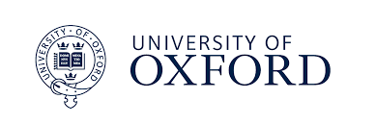


VIVA-GO© COACHING
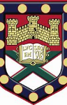

VIVA-GO is a values based, solution focused, quick coaching tool which takes little effort and time for great impact for children, young people and adults.

It has been developed with Oxford University as a Farmington scholarship, and Exeter university as action research for the Masters level National Award for Special Educational Needs Co-ordination (NASENCO). It was created with the help of children, young people and leaders.
In thirty minutes once a month, this simple, fun and effective resource provides supported encouragement, encouragement using a person’s values, inspirations, vision and strengths as motivation and compass, and support for solution focused problem solving. It is an empowering process, which leads to confidence. A quick 30 minutes means choices are solution focused and arrow shaped.
Success can be simply measured and evidenced.
Q&A
What is it? A values-based, solutions-focused coaching tool.
How long, how often? 30 minutes once monthly. Review after three sessions.
Who is it for? Resources and Power points for infant, junior, youth, adult and teams.

How is it done? Individual, pair, group, family or team.
Can it be adapted? Easily adapted and developed for different contexts.
Who leads? Coaches, teachers, parents, mentors, youth or young leaders.

VIVA-GO BENEFITS
- A raising of motivation, metacognition, self-esteem and confidence.
- Empowerment to make personal, achievable changes in areas they choose.
When we change one area of our life, we see we can change other areas.
- A healthy collaborative response to stress, frustration and challenge.

- A building of trust, positive relationships, and a changed view of adults as a resource.
- Improved relationships and communication skills with parents, siblings & peers.
- Confidence in creative decision making around values, choices and actions.
- A better understanding of rules, personal boundaries & time management
- A positive attitude towards learning and aspiration, as each targeted effort leads to success.

HOW DOES VIVA-GO WORK?
VIVA- 15 minutes  Explores values and big vision.  Values  Inspiration,  Vision (Future)  Attributes | VOICE - 15 MINS  Explores short-term vision.  Vision (four weeks)  Obstacles  Inside  Choices  Effort

Values
Inspiration,
Vision (Future)
Attributes

- Carnegie. D. (1953) How to win friends and influence people London, Cedar.

- Carnegie. D. (1953) How to win friends and influence people London, Cedar.

WHY COACH USING VALUES?


- Values are what we stand on to navigate life, like a compass to steer forwards, even when the waves are overwhelming.
So much in our lives- difficulty, stress and change, is outside our control.
- Values help us to connect to what really matters to us.
- Values influence all behaviours, attitudes, decisions and relationships.
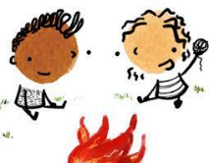
- Values are based on deep beliefs from family, friends and culture.
- To fulfil our future, we need clear goals, vision and a growth mind-set.
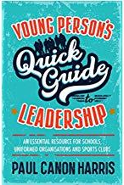
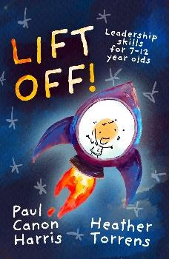
HOW AND WHY?
It was created with a group of pupil spirituality leaders in a school, who had helped to develop a book on leadership skills:
‘Lift off!’ leadership skills for 7-12 year olds’, based on ‘The Quick guide to leadership for young people’

But …

a young boy in the team found it difficult to lead others because he could not lead himself! The challenges in his own life circumstances affected his relationship, behaviour, learning habits and patterns. Through supported encouragement, he discovered his values and his value, and discovered skills to navigate his learning and life approach, which led to him, over time, being chosen as a leader by his peers, teachers and senior leaders. This was the inspiration for VIVA-GO coaching.
IN A NUTSHELL…
The VIVA-GO leader (VIVA means encouragement and life!) listens, reflects back and asks good questions, using the coaching sheet as a prompt, noting the things that matter to the young coachee.
Values, Inspirations, Vision, Attributes,
They then create a short-term target listening to the coachee’s V O I C E.
Vision (short term over a month) Obstacles Inside feelings Choices Effort

The Greek root of the word ‘respect’ is ‘Specto’, ‘to see.’ Through listening to words and observing body language, the coach ’sees’ the drive and hopes of the child, and the coachee takes small step actions to success. The power of belief and the words that are spoken out of those beliefs are key to the motivation that leads to action, and that impacts the future hopes and direction of a child’s life.
STAFFING VIVA-GO
- One or two leaders needed who have 30 minutes or an hour per week. The leader needs to be someone who is a great listener, who could follow and adapt the bank of possible questions and most importantly, someone who believes all children, regardless of barriers, have the potential to thrive through supported encouragement, in personal development, learning, and relationships.
- Example: One person with 30-40 minutes a week would see four children across a month, one per week over a month cycle. One person with two hours per week could support around 12 individuals a month or 48 young people in groups of four.
VIVA- GO works really well in a group setting, as the group learn to support each other. This reaches a larger number of young people. Review after three-months for new potential groups.

SOME QUOTES
VIVA- GO is one of the best things ever in my life. I was really bad, a zero, but now I listen and look and am at 10! I am more happy because I have people who care about me. It makes me be nice. If people talk over you, I get sad. When people say ‘Do you want to talk?’ I am happy.
I learned about other people and I help them.
I know I can do some stuff without giving up.

‘

- Carnegie. D. (1953) How to win friends and influence people London, Cedar.

- Carnegie. D. (1953) How to win friends and influence people London, Cedar.

It’s such a helpful tool to mine for the gold in them. As soon as you start unpacking it you say
‘Ah, there you are!’
because you find out who their inspiration is and who they hold most dearly.

‘

- Carnegie. D. (1953) How to win friends and influence people London, Cedar.

- Carnegie. D. (1953) How to win friends and influence people London, Cedar.

I have found Viva Go very easy to use with my young people. It is simple and highly effective for setting goals and seeing growth. I would recommend it to anyone who is looking for a way to encourage young people and see them grow and develop in their education and personal lives

You have to try it because it will make you better at stuff!
I like best that it makes me better at stuff. I will never give up. I try to not give up.

- Carnegie. D. (1953) How to win friends and influence people London, Cedar.

- Carnegie. D. (1953) How to win friends and influence people London, Cedar.

heather.torrens@coastalpartnership.co.uk

